3.3.2 L evel 1 DFD: Manage Users and Authentication
Inputs include registration data, login credentials, password reset requests, and verification tokens. The process validates input, checks duplicate accounts, stores user data, sends verification email, and creates authenticated sessions.
Outputs include account creation status, login token, password reset link, and error messages.
3.3.3 Level 1 DFD: Tutor Matching
Inputs include search keywords, subject filters, location preference, availability, price range, and student learning history. The process retrieves tutor profiles, applies filters, uses AI ranking, and returns recommended tutors.
Outputs include tutor list, tutor details, availability, and recommendation scores.
3.3.4 Level 1 DFD: Course Management
Inputs include course title, description, modules, lessons, quizzes, resources, enrollment request, and progress updates. The process stores course content, manages enrollments, updates progress, and generates certificates.
Outputs include course catalog, lesson content, enrollment confirmation, progress report, and certificate.
3.3.5 Level 1 DFD: Live Session Management
Inputs include session schedule, join request, chat messages, files, attendance data, and recording metadata. The process creates session room, manages live communication, records attendance, and generates AI summary.
Outputs include session link, chat history, attendance record, recording URL, and summary.
3.3.6 Level 1 DFD: Assignment Marketplace
Inputs include assignment description, attachments, deadline, budget, tutor bid, submission, and review. The process creates assignment listing, collects proposals, manages acceptance, stores submissions, and updates assignment status.
Outputs include listing status, proposal list, accepted bid, submitted work, revision request, and completion status.
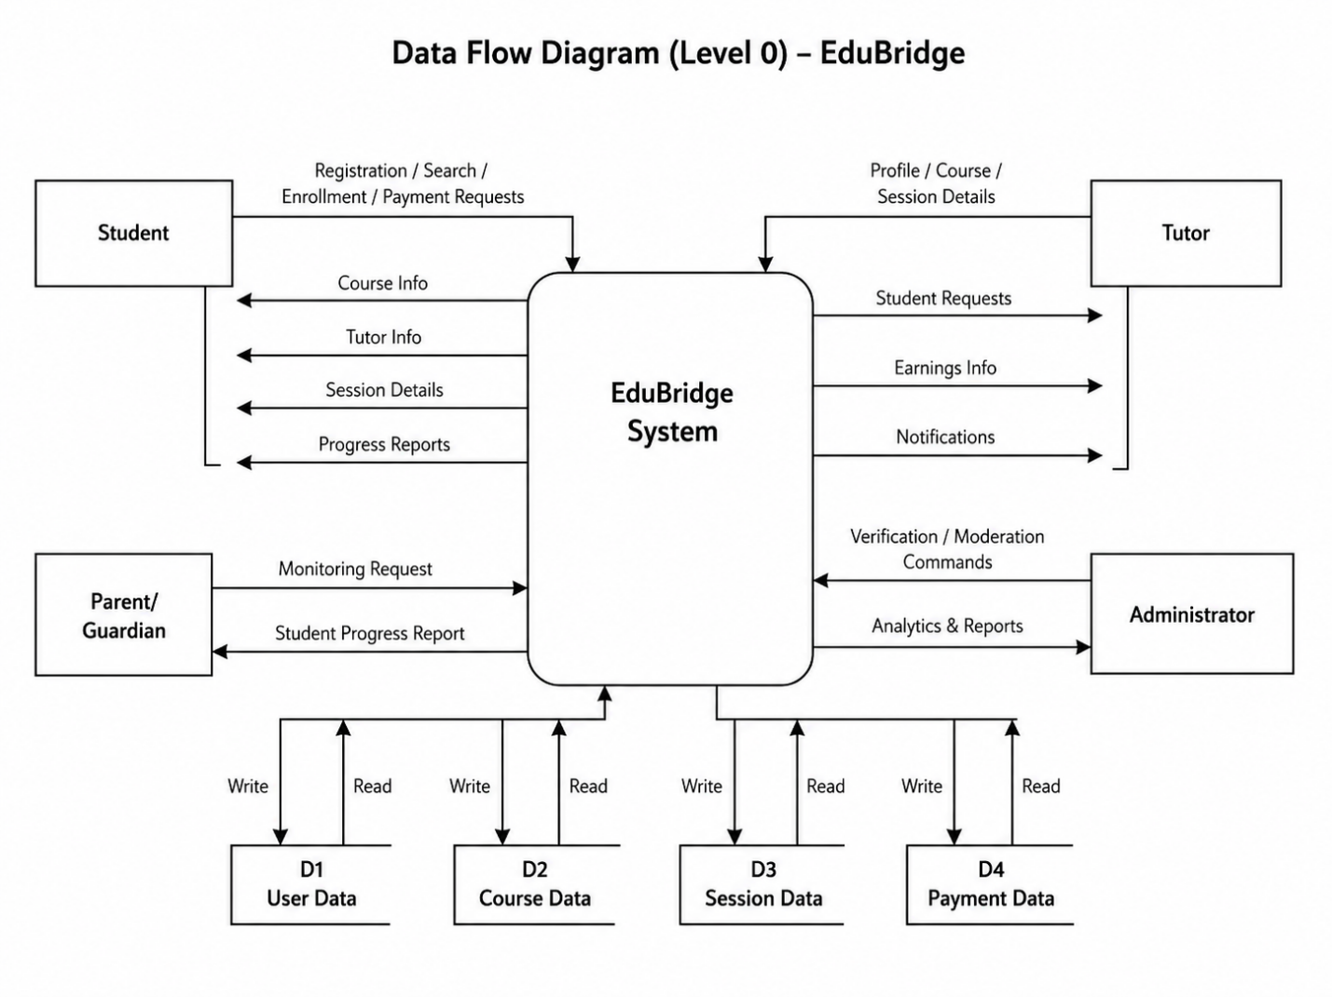
3.3.7 Level 1 DFD: Payment and Escrow
Inputs include payment amount, payment method, transaction type, refund request, and dispute request. The process creates payment intent, contacts gateway, stores transaction, manages escrow, releases funds, or processes refund.
Outputs include payment confirmation, escrow status, payout status, refund decision, and transaction receipt.
3.4 Activity Diagrams
Activity diagrams show step-by-step workflows of major use cases.
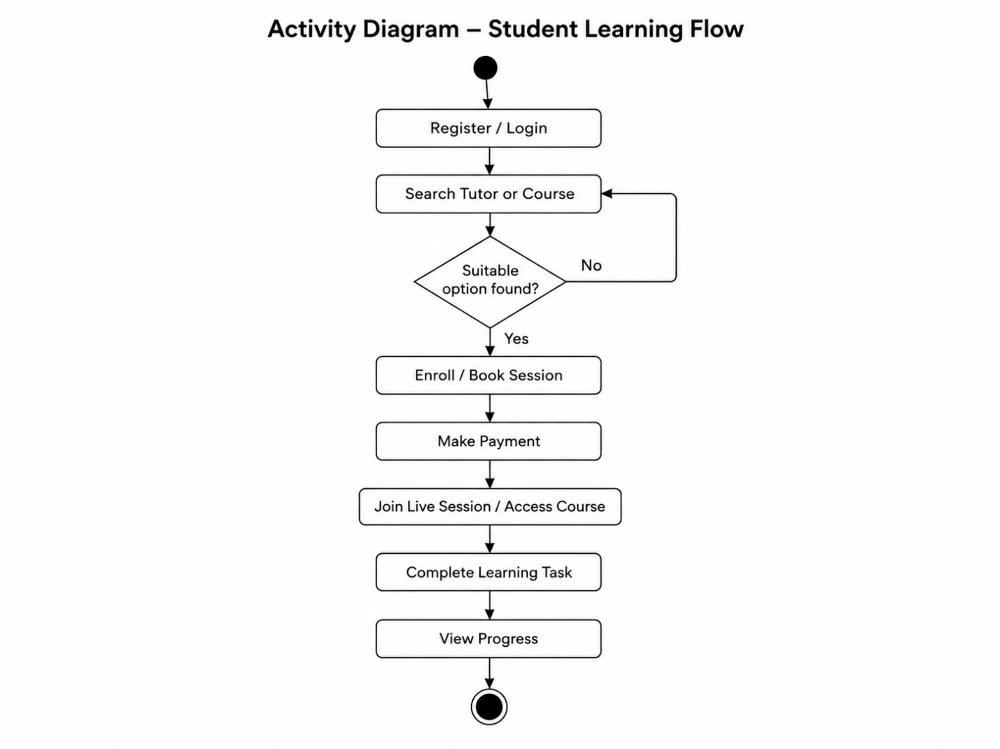
3.5 System Sequence Diagrams
System Sequence Diagrams show interactions between users and the system.
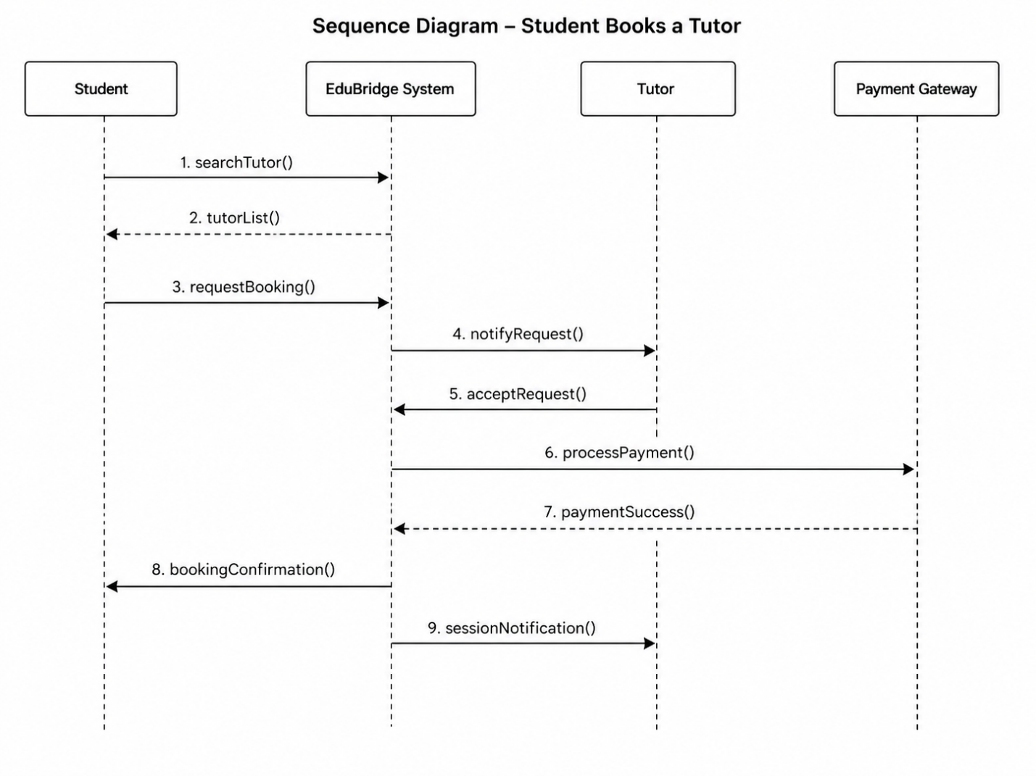
Chapter 4: Design
4.1 Design Overview
The design chapter explains how EduBridge will be structured internally. It includes the architecture, class design, sequence design, database design, interface design, and component responsibilities. The main goal of the design is to convert analysis-level requirements into a clear technical solution.
4.2 Architectural Design
EduBridge follows a layered and service-oriented architecture. The frontend communicates with the backend through APIs. The backend handles business logic and connects with databases, cloud storage, payment gateway, email service, and AI services.
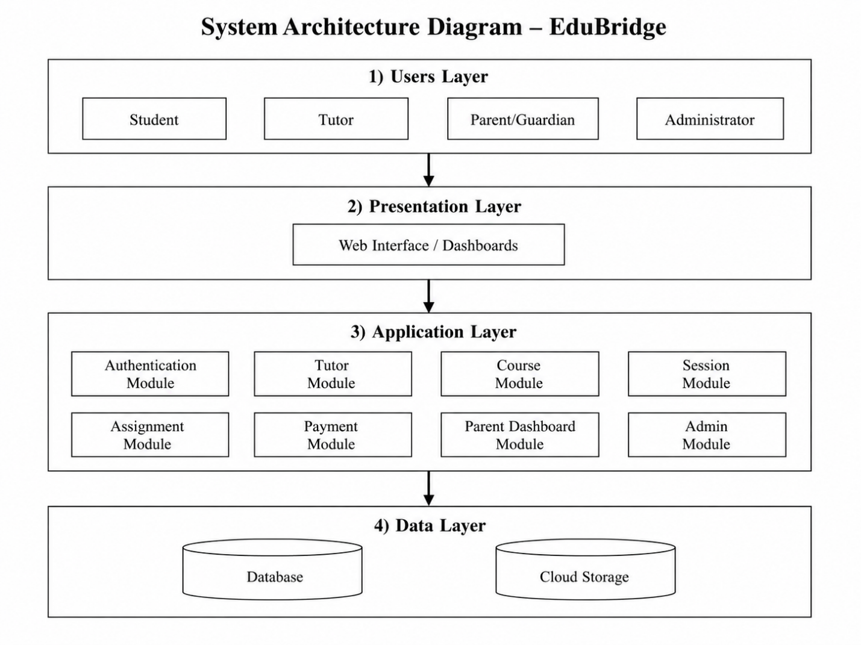
Main Architecture Layers
Layer | Responsibility
Presentation Layer | Provides user interface for students, tutors, parents, and administrators.
API Gateway Layer | Receives client requests, checks authentication, and routes requests to services.
Business Logic Layer | Contains services for users, courses, sessions, assignments, payments, AI, and admin operations.
Data Layer | Stores users, courses, sessions, assignments, payments, reports, and community data.
External Integration Layer | Connects with payment gateway, email service, cloud storage, and AI APIs.

4.3 Component Design
Component | Main Responsibility
User Component | Handles registration, login, profile, and role management.
Tutor Component | Handles tutor profile, verification, availability, and subject listing.
Course Component | Handles course creation, modules, lessons, enrollments, and certificates.
Session Component | Handles scheduling, live rooms, attendance, and summaries.
Assignment Component | Handles assignment posting, bidding, submission, and approval.
Payment Component | Handles transactions, escrow, refunds, and payout records.
Parent Dashboard Component | Handles student progress reports and monitoring.
Community Component | Handles posts, answers, comments, votes, and badges.
AI Component | Handles recommendations, summaries, and learning suggestions.
Admin Component | Handles verification, moderation, disputes, analytics, and audit logs.

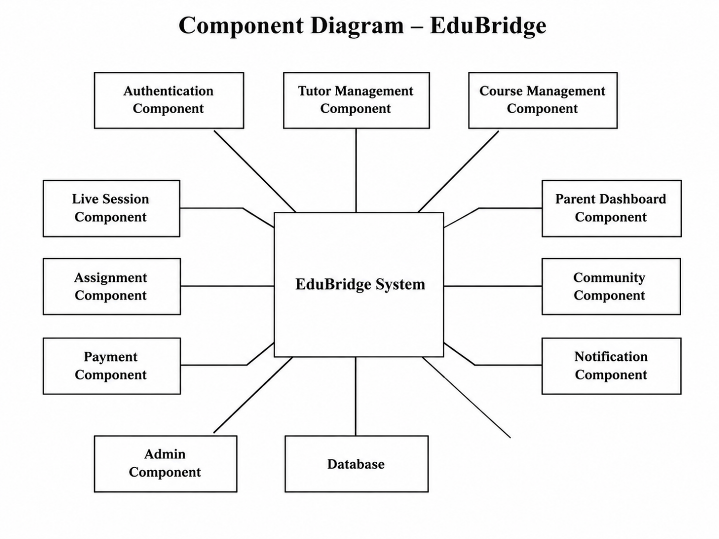
4.4 Important Design Relationships
- Student, Tutor, ParentGuardian, and Administrator inherit from User.
- Tutor owns TutorProfile.
- Tutor creates Course.
- Course contains Module.
- Module contains Lesson.
- Student enrolls in Course through Enrollment.
- Student and Tutor participate in LiveSession.
- Student creates AssignmentRequest.
- Tutor submits Proposal for AssignmentRequest.
- Payment may create EscrowTransaction.
- Student or Tutor may create Review.
- ParentGuardian monitors Student.
- AIReport may be linked with Student, ParentGuardian, or LiveSession.
- Administrator manages verification, disputes, and moderation.
4.5 Sequence Diagrams
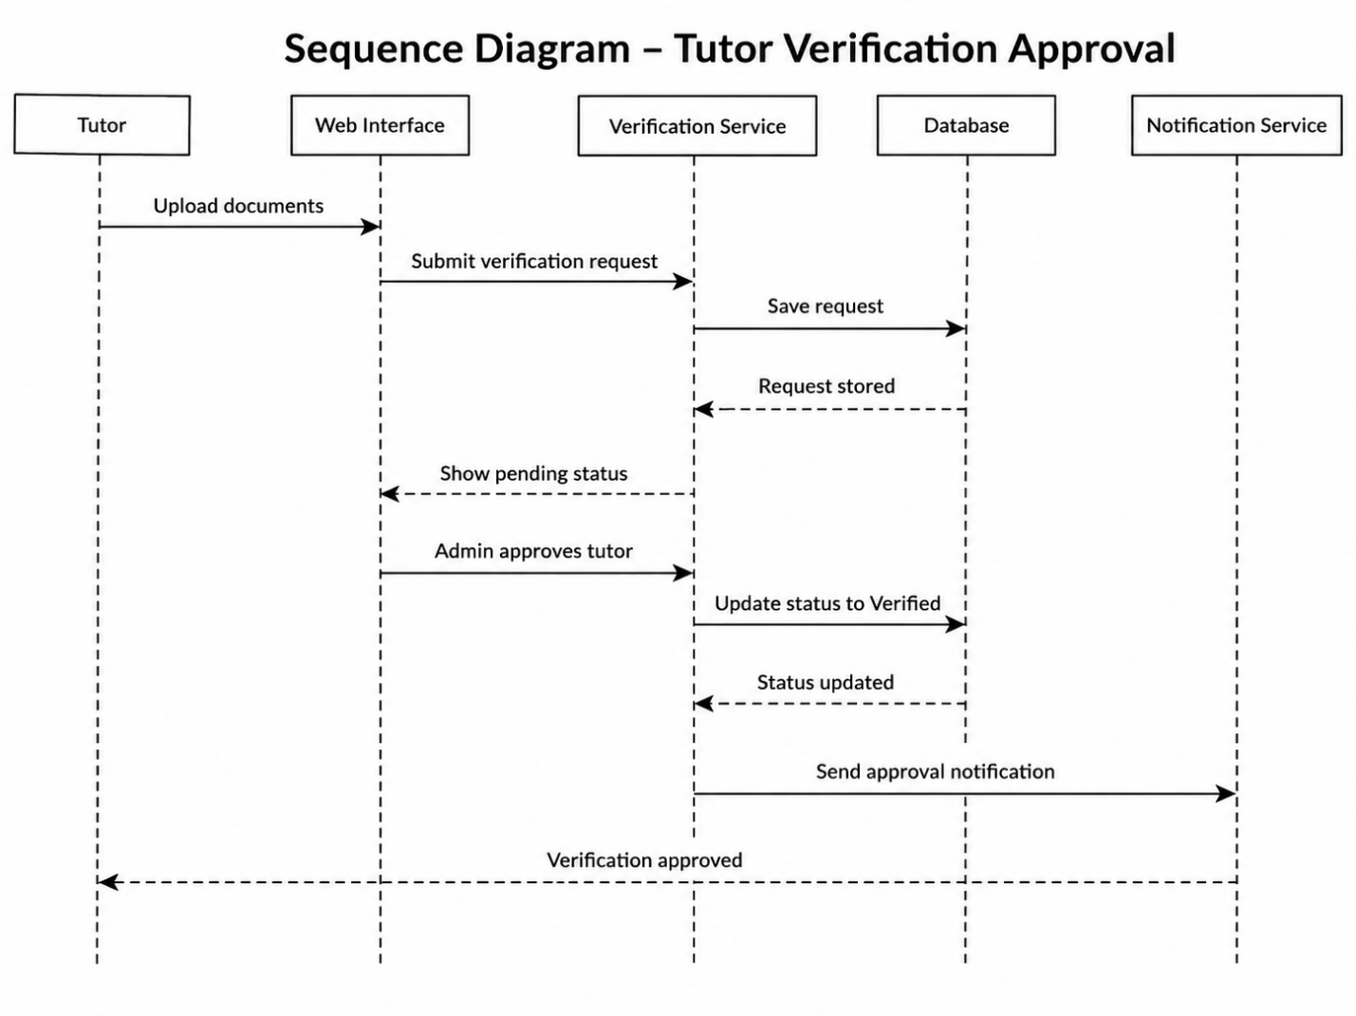

4.6 Database Design
EduBridge requires a database design that supports different users, learning content, live sessions, payments, and reports. The database may be relational or document-based depending on the selected technology.
4.7 Interface Design
EduBridge will provide separate dashboards for each user type. The interface should be clean, responsive, and easy to use. Each dashboard should show the most important actions first.
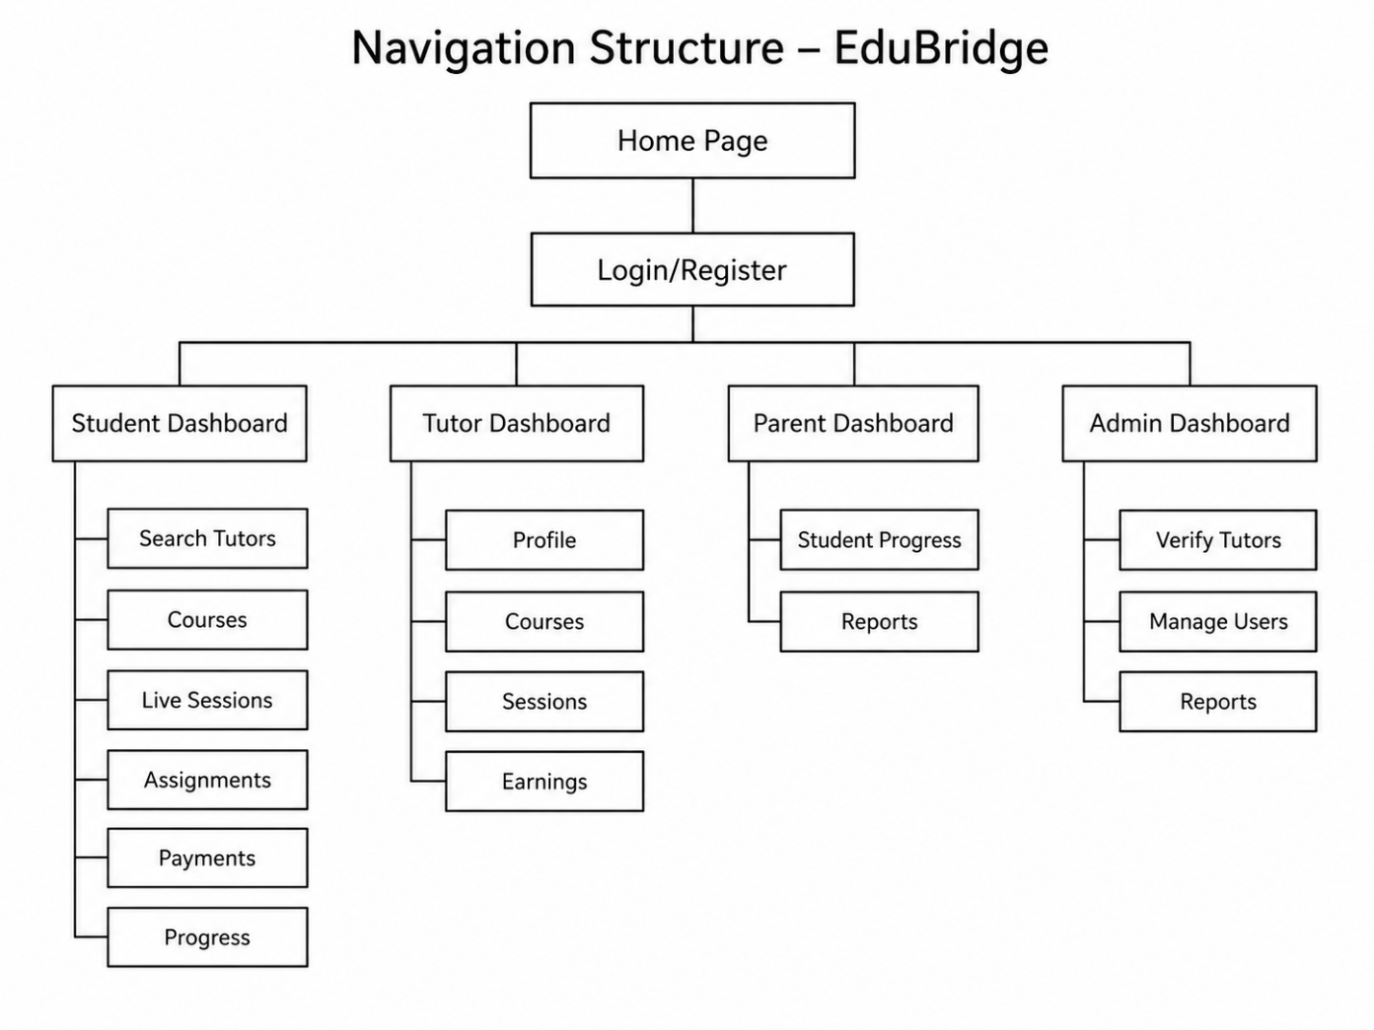
4.8 Interface Flow Examples
Student Search Flow
- Student logs in.
- Student opens the search page.
- Student selects subject and filters.
- System displays tutor results.
- Student opens a tutor profile.
- Student sends request or books session.
Tutor Course Creation Flow
- Tutor logs in.
- Tutor opens course dashboard.
- Tutor creates new course.
- Tutor adds modules and lessons.
- Tutor uploads resources.
- Tutor previews course.
- Tutor publishes course.
Admin Verification Flow
- Admin logs in.
- Admin opens verification queue.
- Admin views tutor documents.
- Admin approves, rejects, or requests more information.
- System updates tutor status.
- Tutor receives notification.
4.9 Security Design
Security is important because EduBridge handles personal data, academic records, documents, and payments. The system will apply the following security controls:
- HTTPS will be used for all communication.
- Passwords will be hashed before storage.
- JWT or secure session tokens will be used for authentication.
- Role-based access control will restrict features by user role.
- Tutor documents will be stored securely.
- Payment data will be handled by the payment gateway.
- Admin actions will be logged.
- Users will be blocked or limited after repeated failed login attempts.
- Parent access will only be allowed for linked students.
- Private files will not be publicly accessible without permission.
4.10 Deployment Design
EduBridge can be deployed using a cloud-based environment. The frontend may be hosted on a web hosting platform, while backend services may run on cloud servers or containers. The database should be hosted securely with backup support. File uploads should be stored in cloud storage. External APIs such as payment, email, and AI services should be configured through secure environment variables.
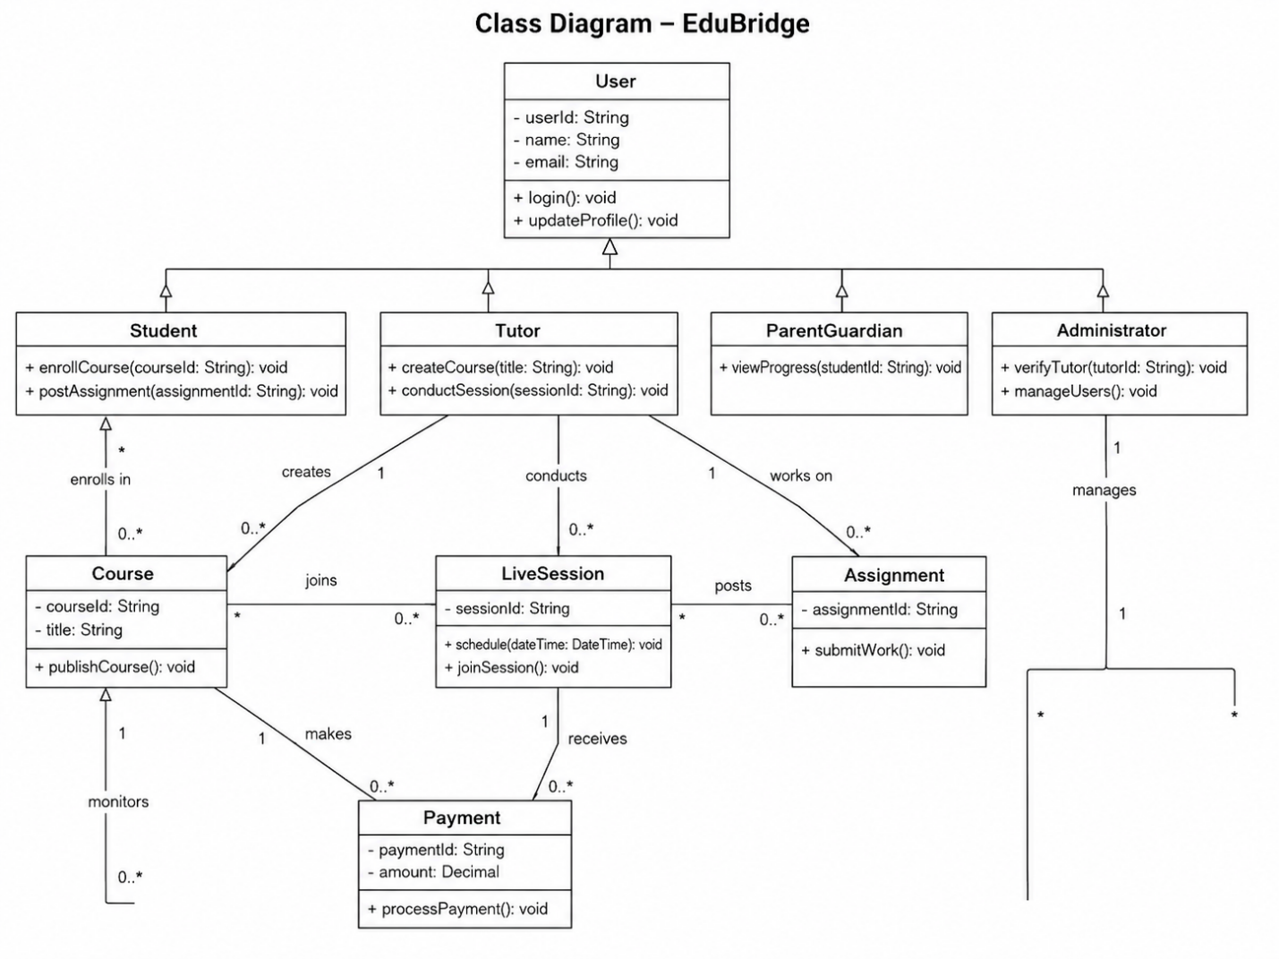
Chapter 5 :Software Testing
5.1 Introduction
Software testing is an important phase of the EduBridge system because the platform handles learning activities, tutor profiles, course enrollment, live sessions, assignments, payments, parent reports and administrative decisions. A small error in any of these areas can affect the trust and usability of the system.
Testing will ensure that the system:
- Accepts valid input data.
- Rejects invalid or incomplete data.
- Allows users to access only their permitted features.
- Correctly connects students with tutors.
- Handles course enrollment and progress tracking.
- Supports live sessions and assignment workflow.
- Processes payments and escrow safely.
- Displays correct reports to parents and administrators.
- Provides useful error messages.
- Protects user data from unauthorized access.
5.2 Test Plan
The test plan defines how the EduBridge system will be tested before final submission. The testing process will cover individual modules, connected modules, complete system flow, security controls, performance behavior and user acceptance.
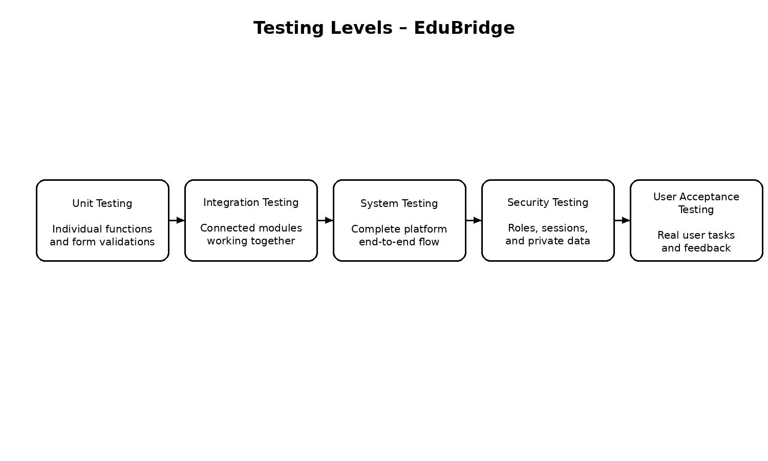
The following testing types will be used:
5.2.1 Unit Testing
Unit testing checks individual functions or small modules separately.
Examples of unit testing in EduBridge include:
- Login form validation.
- Email format validation.
- Tutor search filter validation.
- Course creation form validation.
- Assignment deadline validation.
- Payment amount validation.
- Parent-student linking validation.
- Admin approval action validation.
5.2.2 Integration Testing
Integration testing checks whether different modules work correctly together
Examples include:
- Student registration with email verification.
- Tutor verification with admin approval.
- Course enrollment with payment processing.
- Live session scheduling with notification delivery.
- Assignment acceptance with escrow creation.
- Parent dashboard with student progress data.
- Admin dispute resolution with payment refund or release.
5.2.3 System Testing
System testing checks the complete EduBridge platform as a whole.
Examples include:
- Student registers, searches tutor, books session and makes payment.
- Tutor creates course and student enrolls in it.
- Student posts assignment and tutor submits work.
- Parent logs in and views student performance report.
- Admin verifies tutor and handles user reports.
5.2.4 Security Testing
Security testing verifies whether the system protects user accounts, private data, documents and payment-related information.
Security testing will check:
- Invalid login attempts.
- Password protection.
- Session timeout.
- Student access restrictions.
- Parent access restrictions.
- Admin-only feature protection.
- Secure file upload.
- Payment data protection.
5.2.5 User Acceptance Testing
User acceptance testing checks whether the system is understandable and useful for actual users. Sample students, tutors, parents and administrators can test the system and provide feedback.
User acceptance testing will focus on:
- Ease of navigation.
- Clarity of forms.
- Accuracy of displayed information.
- Simplicity of dashboards.
- Error messages.
- Completion of main tasks without confusion.
5.3 Features Selected for Testing
The following EduBridge features will be selected for testing:
- User registration and login.
- Email verification and password reset.
- Tutor profile creation.
- Tutor verification by administrator.
- Tutor search and filtering.
- Student-tutor request and proposal.
- Course creation and publishing.
- Course enrollment and progress tracking.
- Live session joining and attendance.
- Assignment posting and proposal submission.
- Assignment submission and approval.
- Payment and escrow management.
- Parent/guardian dashboard.
- Community post and Q&A feature.
- Admin user management.
- Admin dispute handling.
- Notification system.
- Role-based access control.
- Report generation.
- File upload validation.
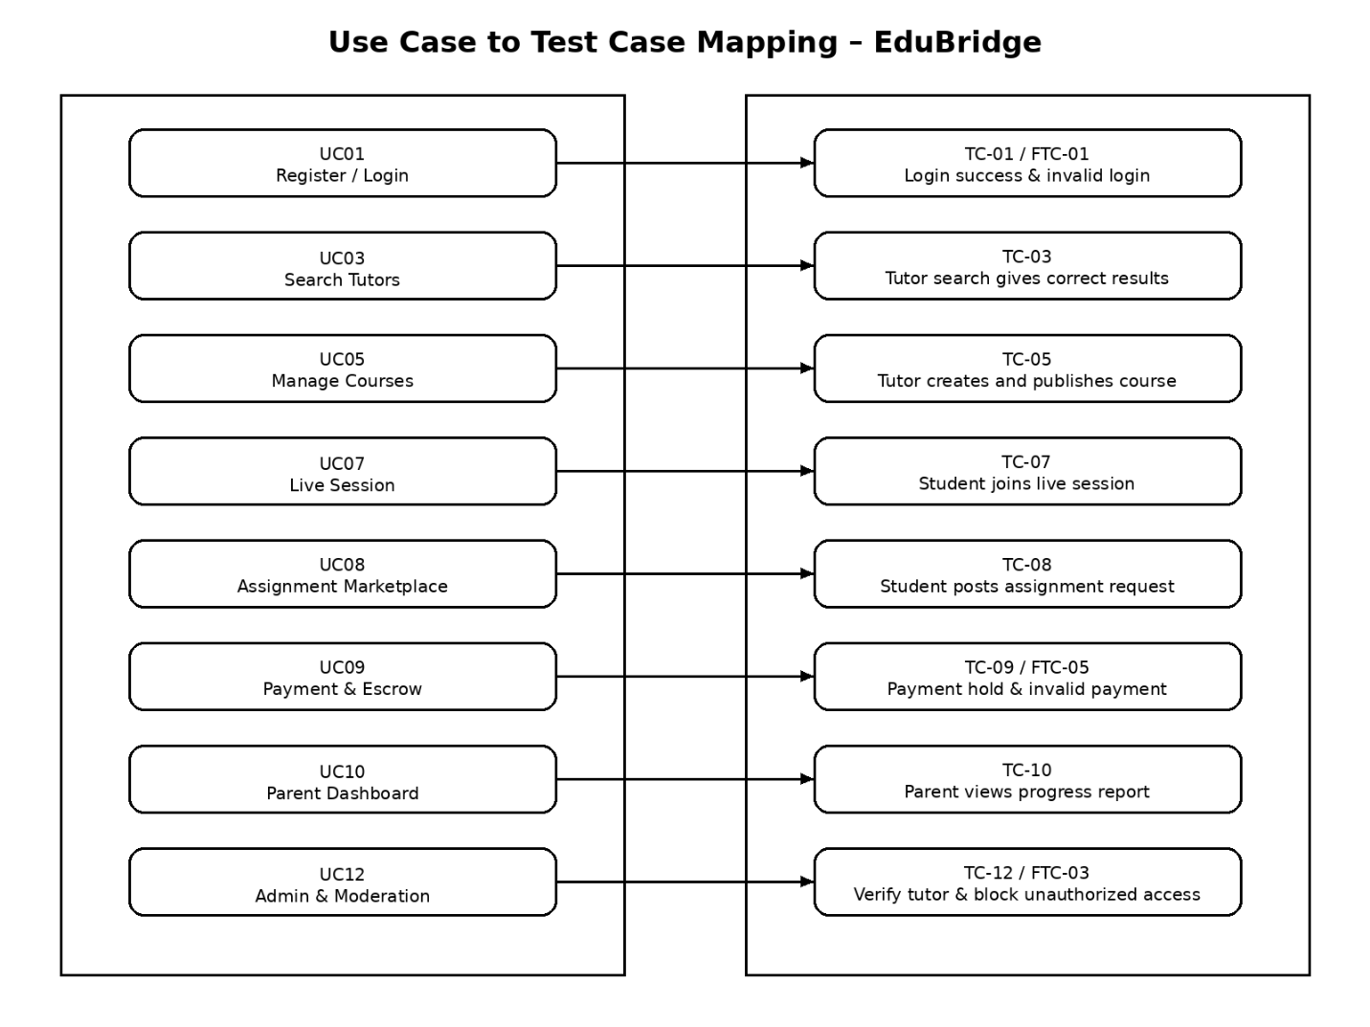
5.4 Testing Workflow
The general testing workflow is:
- Select use case or module.
- Prepare test data.
- Execute test case.
- Compare actual result with expected result.
- Mark test as pass if the result is correct.
- Record defect if the result is incorrect.
- Fix the defect.
- Retest the affected module.
- Perform regression testing.
- Prepare test summary report.
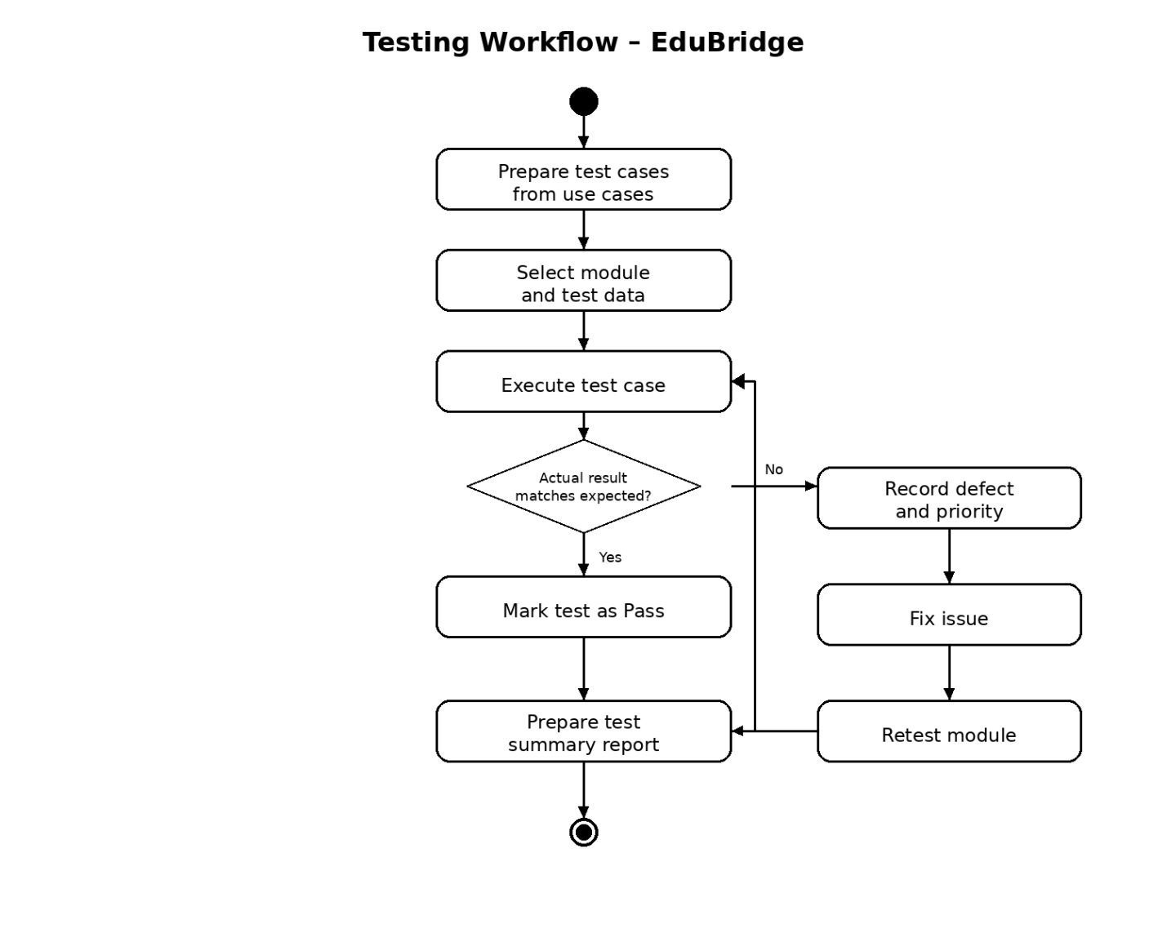
5.5 Normal Test Cases
5.5.1 Login With Valid Credentials
Field | Description
Test ID | TC-01
Related Use Case | UC01 – User Registration and Authentication
Module | Authentication
Objective | Verify that a registered user can log in successfully
Preconditions | User account exists and is active
Input | Correct email and password
Expected Result | User dashboard opens according to user role
Status | Pass if correct dashboard opens
5.5.2 Login With Invalid Password
Field | Description
Test ID | TC-02
Related Use Case | UC01 – User Registration and Authentication
Module | Authentication
Objective | Verify that invalid login is rejected
Preconditions | User account exists
Input | Correct email and wrong password
Expected Result | Error message is displayed and access is denied
Status | Pass if user is not logged in
5.5.3 Search Tutor
Field | Description
Test ID | TC-03
Related Use Case | UC03 – Browse and Search Tutors
Module | Tutor Search
Objective | Verify that students can search tutors by subject and filters
Preconditions | Student is logged in and tutor profiles exist
Input | Subject, rating, availability or price filter
Expected Result | Matching tutor list is displayed
Status | Pass if relevant tutors appear
5.5.4 Send Tutoring Request
Field | Description
Test ID | TC-04
Related Use Case | UC04 – Student–Tutor Request and Proposal
Module | Matchmaking
Objective | Verify that student can send a tutoring request
Preconditions | Student is logged in and tutor profile is available
Input | Tutoring request details
Expected Result | Request is saved and tutor receives notification
Status | Pass if request appears for tutor
5.5.5 Create Course
Field | Description
Test ID | TC-05
Related Use Case | UC05 – Course Creation and Management
Module | Course Management
Objective | Verify that tutor can create a course
Preconditions | Tutor is logged in
Input | Course title, description, modules and resources
Expected Result | Course is saved as draft or published
Status | Pass if course appears in tutor dashboard
5.5.6 Enroll in Course
Field | Description
Test ID | TC-06
Related Use Case | UC06 – Course Enrollment and Progress Tracking
Module | Enrollment
Objective | Verify that student can enroll in a course
Preconditions | Course is published
Input | Student selects enroll option
Expected Result | Enrollment record is created
Status | Pass if course appears in student dashboard
5.5.7 Join Live Session
Field | Description
Test ID | TC-07
Related Use Case | UC07 – Live Interactive Session
Module | Live Session
Objective | Verify that student and tutor can join a scheduled session
Preconditions | Session is scheduled
Input | User clicks Join Session
Expected Result | Live session room opens
Status | Pass if both users can join successfully
5.5.8 Post Assignment Request
Field | Description
Test ID | TC-08
Related Use Case | UC08 – Assignments and Marketplace
Module | Assignment Marketplace
Objective | Verify that student can post assignment request
Preconditions | Student is logged in
Input | Assignment title, description, deadline and budget
Expected Result | Assignment request is saved and visible to tutors
Status | Pass if request appears in marketplace
5.5.9 Process Payment and Escrow
Field | Description
Test ID | TC-09
Related Use Case | UC09 – Payments and Escrow Management
Module | Payment
Objective | Verify that payment is processed and escrow is created
Preconditions | Student has selected paid service
Input | Valid payment details
Expected Result | Payment is successful and escrow status is updated
Status | Pass if transaction is stored correctly
5.5.10 View Parent Dashboard
Field | Description
Test ID | TC-10
Related Use Case | UC10 – Parent/Guardian Dashboard
Module | Parent Dashboard
Objective | Verify that parent can view linked student progress
Preconditions | Parent account is linked with student account
Input | Parent selects student dashboard
Expected Result | Progress, courses and attendance are displayed
Status | Pass if correct student data appears
5.5.11 Create Community Post
Field | Description
Test ID | TC-11
Related Use Case | UC11 – Community Interaction and Q&A
Module | Community
Objective | Verify that user can create a question or discussion post
Preconditions | User is logged in
Input | Post title and description
Expected Result | Post is published in community section
Status | Pass if post is visible
5.5.12 Verify Tutor
Field | Description
Test ID | TC-12
Related Use Case | UC12 – Administration and Moderation
Module | Admin Management
Objective | Verify that admin can approve tutor verification
Preconditions | Tutor has submitted verification documents
Input | Admin selects approve option
Expected Result | Tutor status changes to verified
Status | Pass if verified badge appears on tutor profile
5.6 Failure Scenario Test Cases
5.6.1 Duplicate Email Registration
Field | Description
Test ID | FTC-01
Scenario | User tries to register with an email that already exists
Expected Result | System rejects registration and displays message
Status | Pass if duplicate account is not created
5.6.2 Course Enrollment Without Payment
Field | Description
Test ID | FTC-02
Scenario | Student tries to access a paid course without successful payment
Expected Result | Access is blocked until payment is completed
Status | Pass if course content remains locked
5.6.3 Unauthorized Admin Access
Field | Description
Test ID | FTC-03
Scenario | Student or tutor tries to open admin dashboard
Expected Result | Access is denied
Status | Pass if user is redirected or shown an error
5.6.4 Tutor Uploads Unsupported File
Field | Description
Test ID | FTC-04
Scenario | Tutor uploads unsupported document type for verification
Expected Result | File is rejected and allowed formats are displayed
Status | Pass if invalid file is not stored
5.6.5 Invalid Payment Amount
Field | Description
Test ID | FTC-05
Scenario | System receives zero or negative payment amount
Expected Result | Payment is rejected
Status | Pass if invalid transaction is not processed
5.6.6 Assignment Without Description
Field | Description
Test ID | FTC-06
Scenario | Student submits assignment request without description
Expected Result | Submission is blocked and validation message appears
Status | Pass if incomplete request is not saved
5.6.7 Expired Session Link
Field | Description
Test ID | FTC-07
Scenario | User tries to join a live session after the allowed time
Expected Result | System displays session expired or unavailable message
Status | Pass if user cannot join expired session
5.6.8 Parent Views Unlinked Student
Field | Description
Test ID | FTC-08
Scenario | Parent tries to view a student who is not linked to their account
Expected Result | Access is denied
Status | Pass if private student data is not shown
5.6.9 AI Service Unavailable
Field | Description
Test ID | FTC-09
Scenario | AI recommendation service is temporarily unavailable
Expected Result | System displays normal search results without AI ranking
Status | Pass if system continues working with fallback results
5.6.10 Database Connection Failure
Field | Description
Test ID | FTC-10
Scenario | Database is temporarily unavailable
Expected Result | Safe error message is displayed
Status | Pass if technical details are not exposed
5.7 Security Testing
Security testing will verify whether EduBridge protects user accounts, private records and payment-related information.
Security Area | Test
Authentication | Invalid email or password should be rejected
Authorization | Users cannot access features outside their role
Password Storage | Passwords should not be stored as plain text
Session Management | Inactive sessions should expire
Input Validation | Invalid and unsafe input should be rejected
File Upload | Unsupported or dangerous files should be blocked
Parent Privacy | Parent can only view linked student data
Admin Access | Only administrators can access admin dashboard
Payment Safety | Payment status cannot be changed by unauthorized users
Audit Logging | Important admin actions should be recorded
5.8 Performance Testing
Performance testing will check whether EduBridge works smoothly under normal usage conditions.
Test | Expected Result
Open login page | Page loads without unnecessary delay
Search tutor by subject | Tutor results appear within reasonable time
Open course page | Course details are displayed correctly
Join live session | Session page opens successfully
Submit assignment request | Confirmation appears after submission
Process payment | Payment status updates after gateway response
Open parent dashboard | Student progress values are displayed correctly
Generate admin report | Report is displayed or exported successfully
The exact response time may depend on internet speed, server configuration and number of users. However, common pages should load quickly enough for normal academic use.
5.9 User Acceptance Testing
User acceptance testing will be performed with sample users from each role. The purpose is to check whether EduBridge is easy to use and suitable for real users.
5.9.1 Student Evaluation
Students will check whether they can:
- Register and log in easily.
- Search tutors by subject.
- View tutor profiles.
- Enroll in courses.
- Join live sessions.
- Post assignment requests.
- Make payments.
- View progress.
5.9.2 Tutor Evaluation
Tutors will check whether they can:
- Create and update tutor profile.
- Upload verification documents.
- Create courses.
- Respond to student requests.
- Conduct live sessions.
- Submit assignment work.
- View earnings.
5.9.3 Parent/Guardian Evaluation
Parents or guardians will check whether they can:
- Log in to the parent dashboard.
- View linked student progress.
- Check enrolled courses.
- View attendance or session activity.
- Read AI-generated progress summary.
5.9.4 Administrator Evaluation
Administrators will check whether they can:
- View pending tutor verification requests.
- Approve or reject tutors.
- Manage users.
- View payment disputes.
- Moderate community content.
- Generate system reports.
5.9.5 Acceptance Criteria
The system will be accepted if:
- All core use cases work correctly.
- Users can access dashboards according to their roles.
- Tutor verification works properly.
- Students can search tutors and enroll in courses.
- Live sessions can be joined by student and tutor.
- Assignment marketplace workflow works correctly.
- Payments and escrow status are handled safely.
- Parent dashboard displays correct student information.
- Unauthorized access is blocked.
- No critical defect remains unresolved.
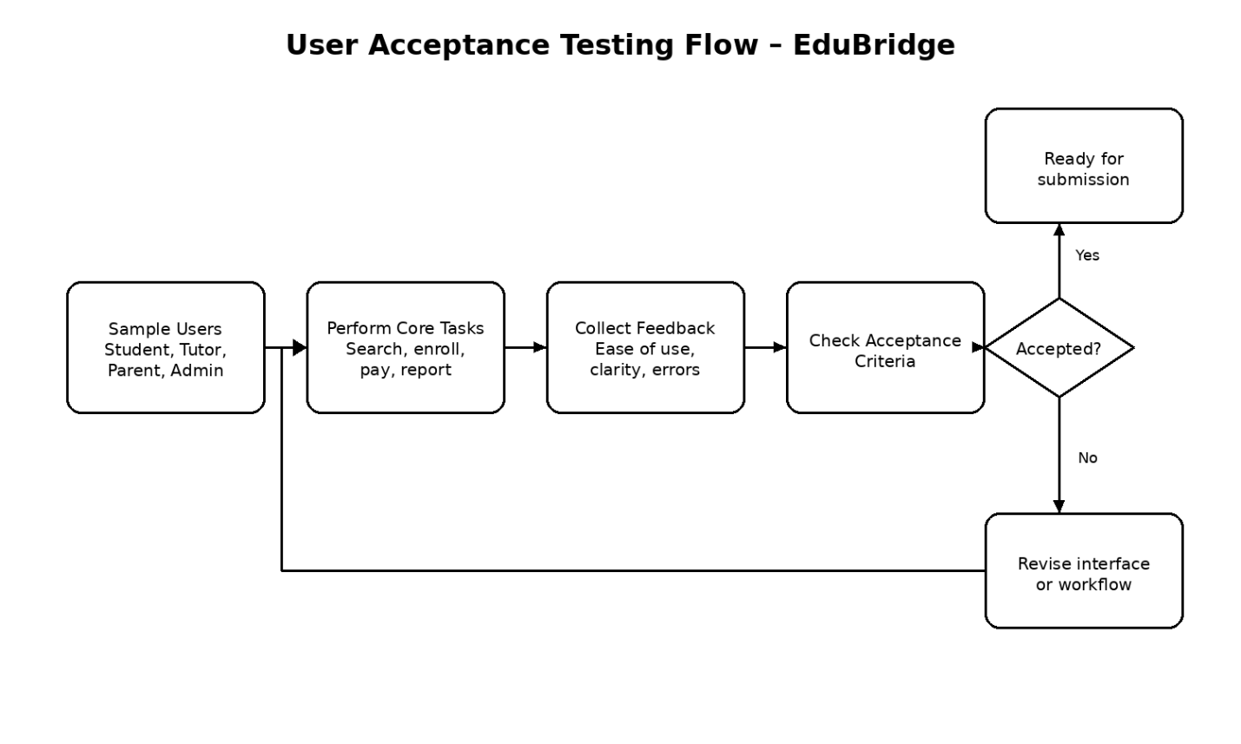
5.10 Defect Handling Process
When an issue is found during testing, the development team will follow a proper defect handling process.
The steps are:
- Record the defect.
- Assign a defect ID.
- Identify the affected module.
- Write steps to reproduce the issue.
- Mention expected and actual result.
- Set defect priority.
- Assign the defect to developer.
- Fix the issue.
- Retest the same scenario.
- Perform regression testing.
- Close the defect after successful verification.
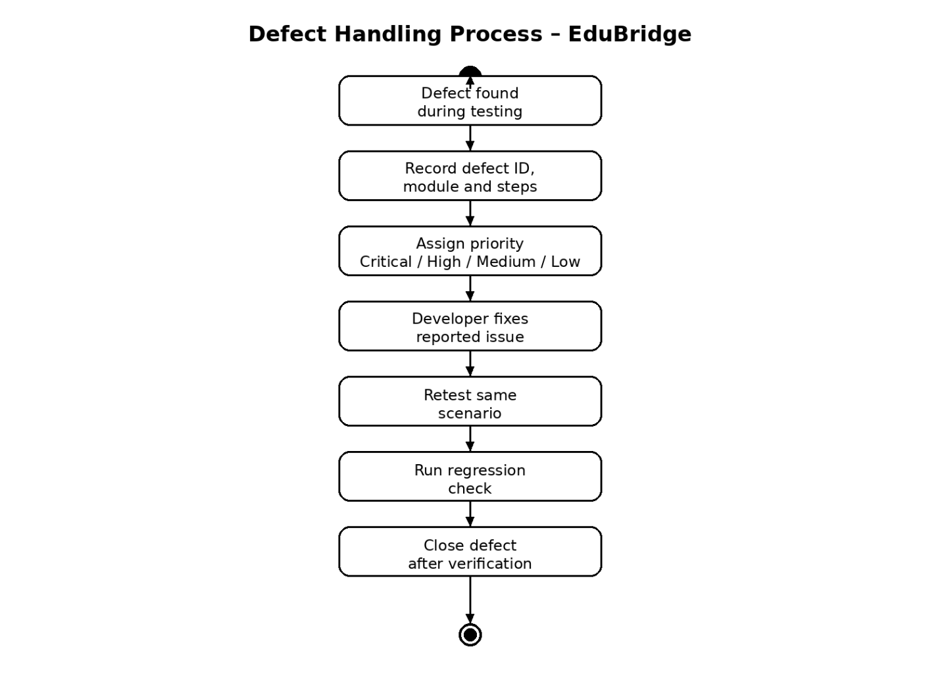
5.10.1 Defect Priority Levels
Priority | Description
Critical | Stops a major system function such as login, payment or enrollment
High | Affects an important feature but system can still be used
Medium | Causes inconvenience but has a workaround
Low | Minor interface, spelling or formatting issue

